**DAILY ONLINE ACTIVITIES SUMMARY**

|  |  |  |  |  |  |  |  |  |
| --- | --- | --- | --- | --- | --- | --- | --- | --- |
| **Date:** | **15-06-2020** | | | | | **Name:** | **Anusha** | |
| **Sem & Sec** | **VIII Semester & A Section** | | | | | **USN:** | **4AL16CS014** | |
| **Online Test Summary** | | | | | | | | |
| **Subject** | | **SMS** | | | | | | |
| **Max. Marks** | | **60** | | **Score** | | | **--** | |
| **Certification Course Summary** | | | | | | | | |
| **Course** | **Introduction to Amazon Elastic Compute Cloud (EC2)** | | | | | | | |
| **Certificate Provider** | | | **Amazon Web Service** | | **Duration** | | | **10 minutes** |
| **Coding Challenges** | | | | | | | | |
| **Problem Statement: Write a program in for binary reversal** | | | | | | | | |
| **Status: COMPLETED** | | | | | | | | |
| **Uploaded the report in Github** | | | | | **YES** | | | |
| **If yes Repository name** | | | | | **anushasuvarna-014** | | | |
| **Uploaded the report in slack** | | | | | **YES** | | | |

Online Test Details:

NIL

Certification Course 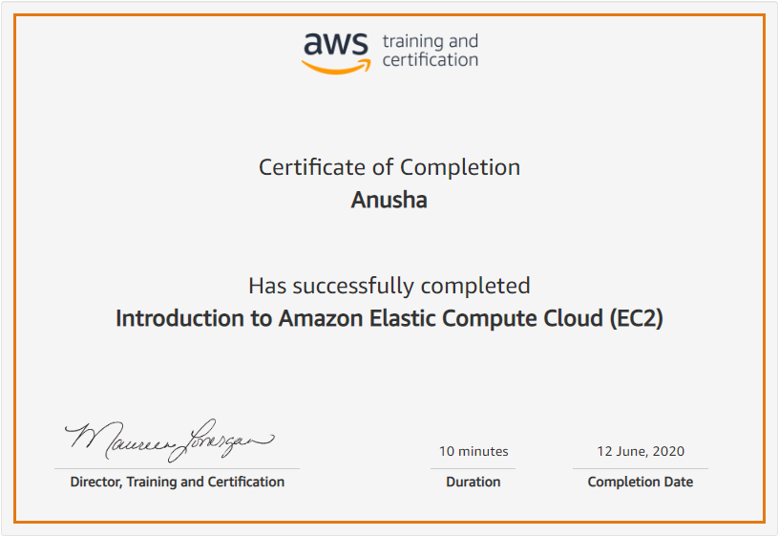

Coding Challenges Details:

|  |
| --- |
|  |
|  |
|  |
|  |
|  |
|  |
|  |
|  |
|  |
|  |
|  |
|  |
|  |
|  |
|  |
|  |
|  |
|  |
|  |
|  |
|  |
|  |
|  |
|  |
|  |
|  |
|  |
|  |
|  |
|  |
|  |
|  |
|  |
|  |
|  |
|  |
|  |
|  |
|  |
|  |
|  |
|  |
|  |
|  |
|  |
|  |
|  |
|  |
|  |
|  |
|  |
|  |
|  |
|  |

**Program:**

**#include<stdio.h>**

**unsigned int reverseBits(unsigned int n)**

**{**

**unsigned int rev = 0;**

**while (n > 0)**

**{**

**rev <<= 1;**

**if (n & 1 == 1)**

**rev ^= 1;**

**n >>= 1;**

**}**

**return rev;**

**}**

**int main()**

**{**

**unsigned int n ;**

**printf("Enter the number :\n");**

**scanf("%d",&n);**

**printf("%d", reverseBits(n));**

**printf("\n");**

**return 0;**

**}**